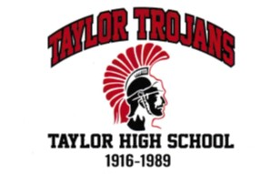
THE 24TH ANNUAL TAYLOR ALL-SCHOOL REUNION

It’s back. Mark your calendar for July 16th 2022. Finally, after 2 years of not being able to gather in large groups we can now bring all Taylor graduates together for an evening of reacquainting and socializing. Hosted by the classes of 1970, 1971, and 1972 at Castle Hill Supper Club, Merrillan, WI. The evening begins at 4PM with cocktails and buffet dinner at 5:30PM. To help fund future reunions there will be many fantastic raffle prizes, a 50/50 raffle, and watch for a glimpse of a large specialty raffle in your invitation. Door prizes, class dedications, and Taylor School trivia will also be included in the program. Watch your email or postal mail for invitations to come to you very soon. Hope to see you there!

